SIMAPP Key binding extraction and share method
MSFS
- log in SIMAPP and click setting
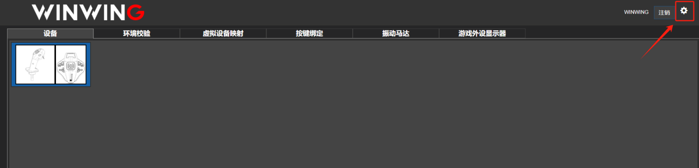
In the MSFS2020 config logcation, select the game start method, check if the game path setting is right
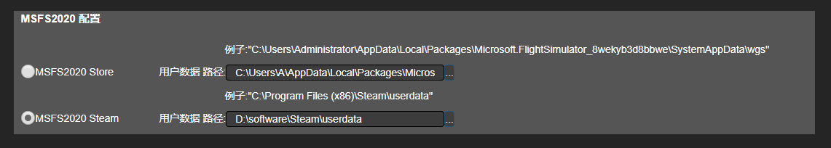

- Open MSFS game, in the setting page, click control setting
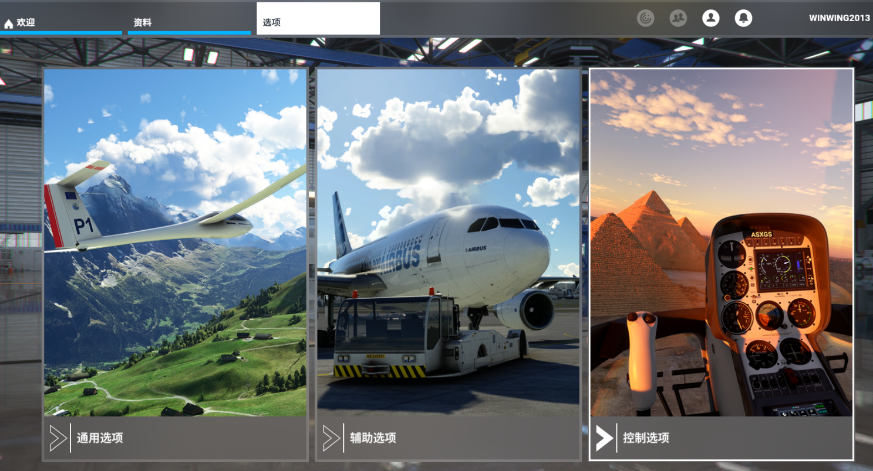

Select Winwing device, click and open the pre-setting

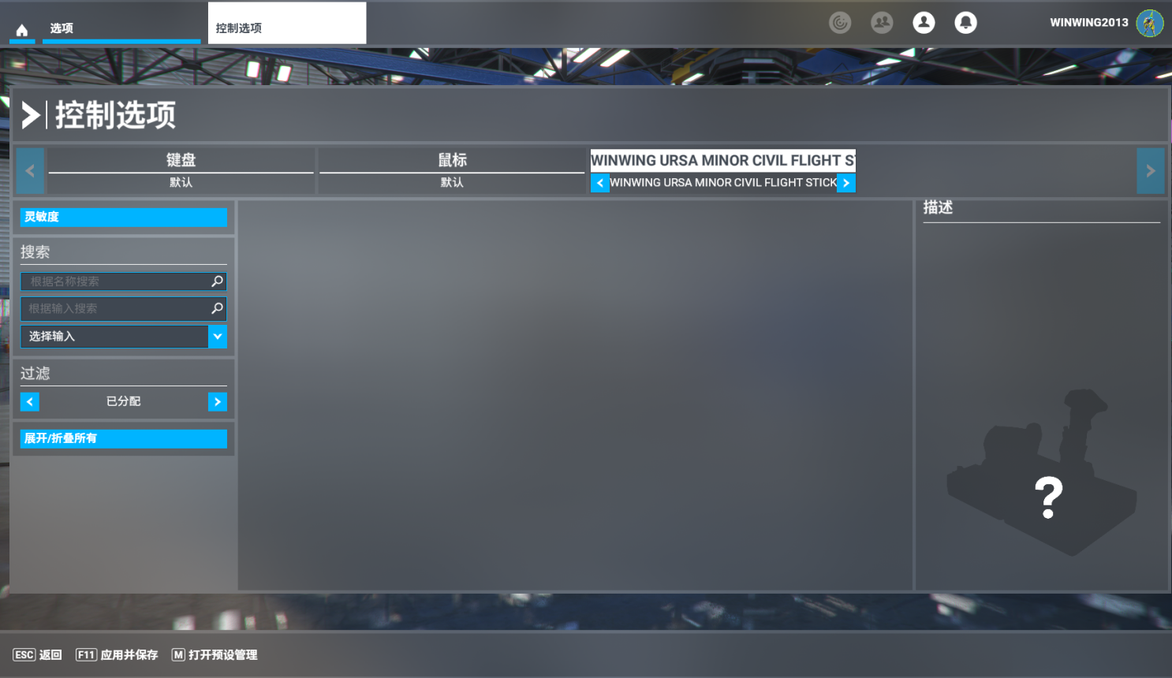
Click add new( First time use the device, there is no key config file, need to create a config for key binding)
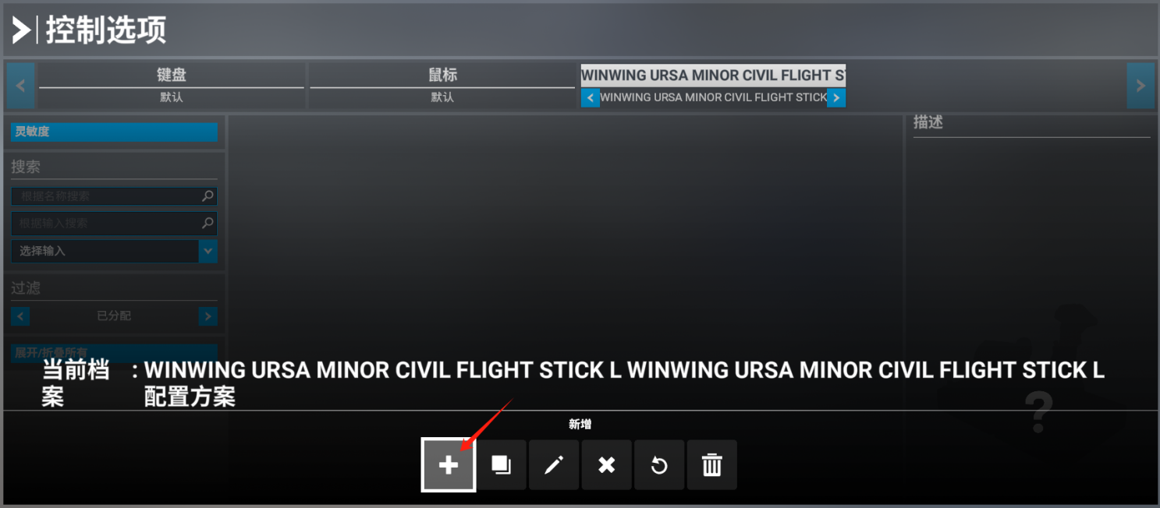
Create a new key config and click OK
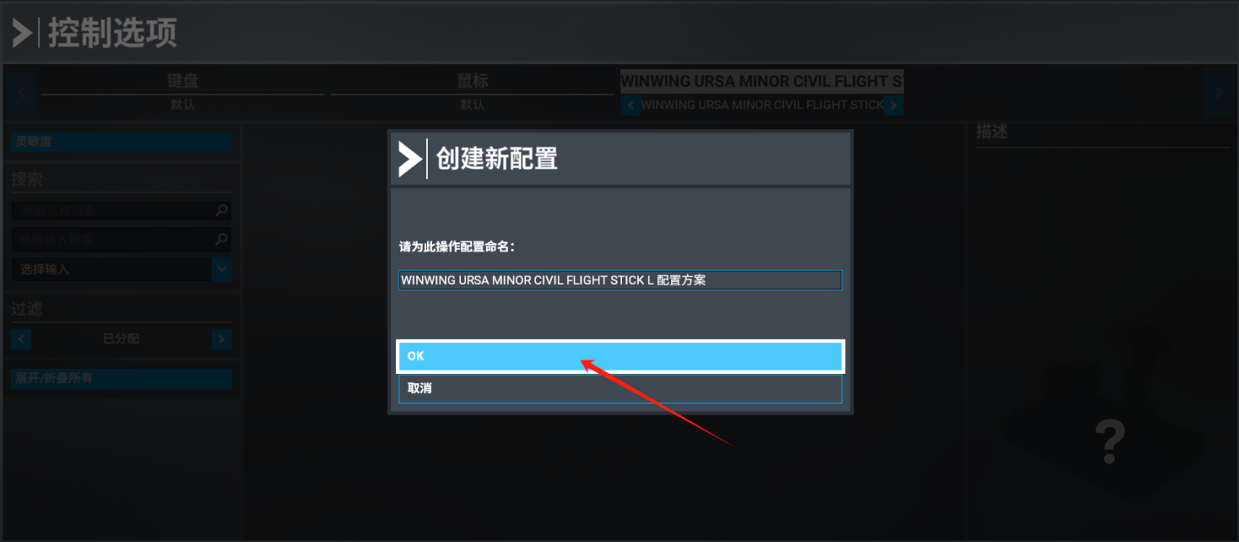
Click select to unfold all, it is successfully created as shown in the picture below
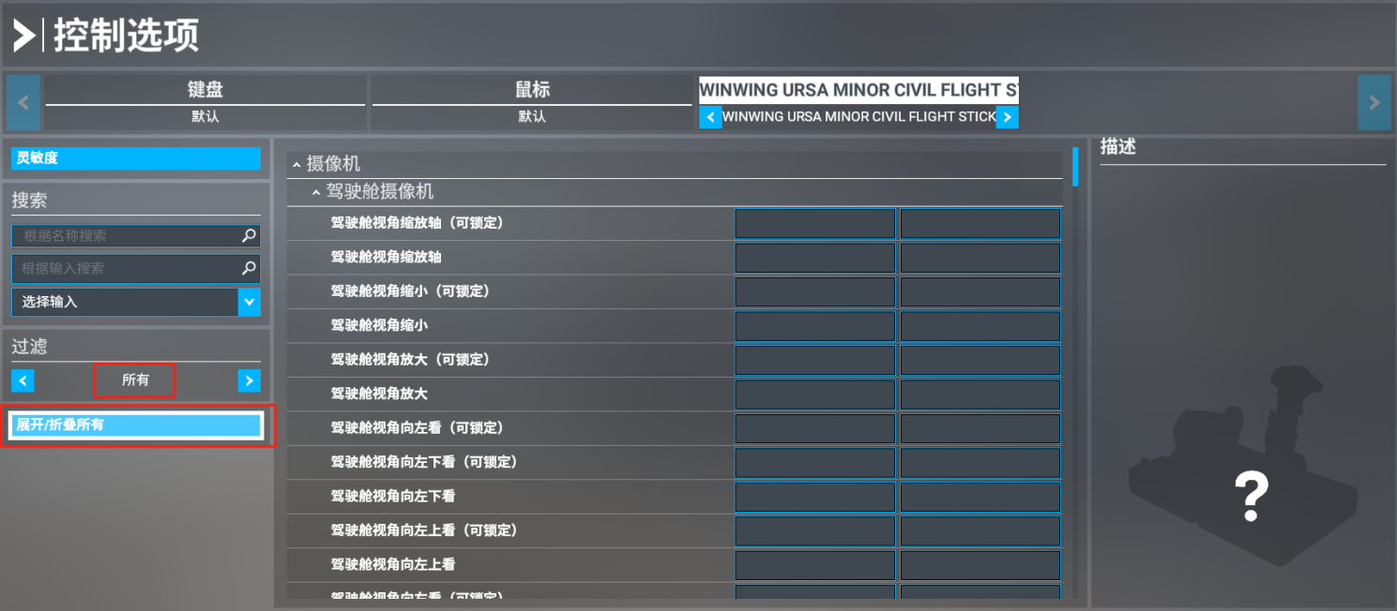
- Open SIMAPP, in key binding page, select product and game
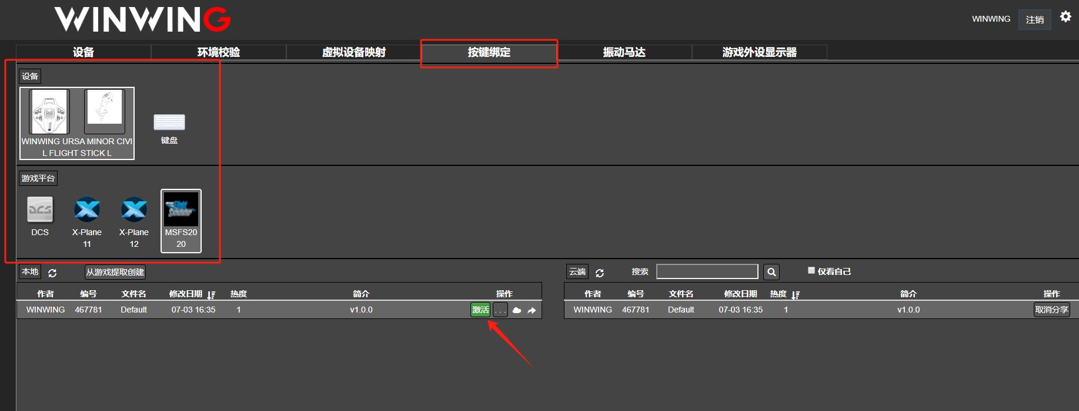
Select the config that was created in game, then click run(Before click run, please check the game path is correct in the setting, then close the game to active it)
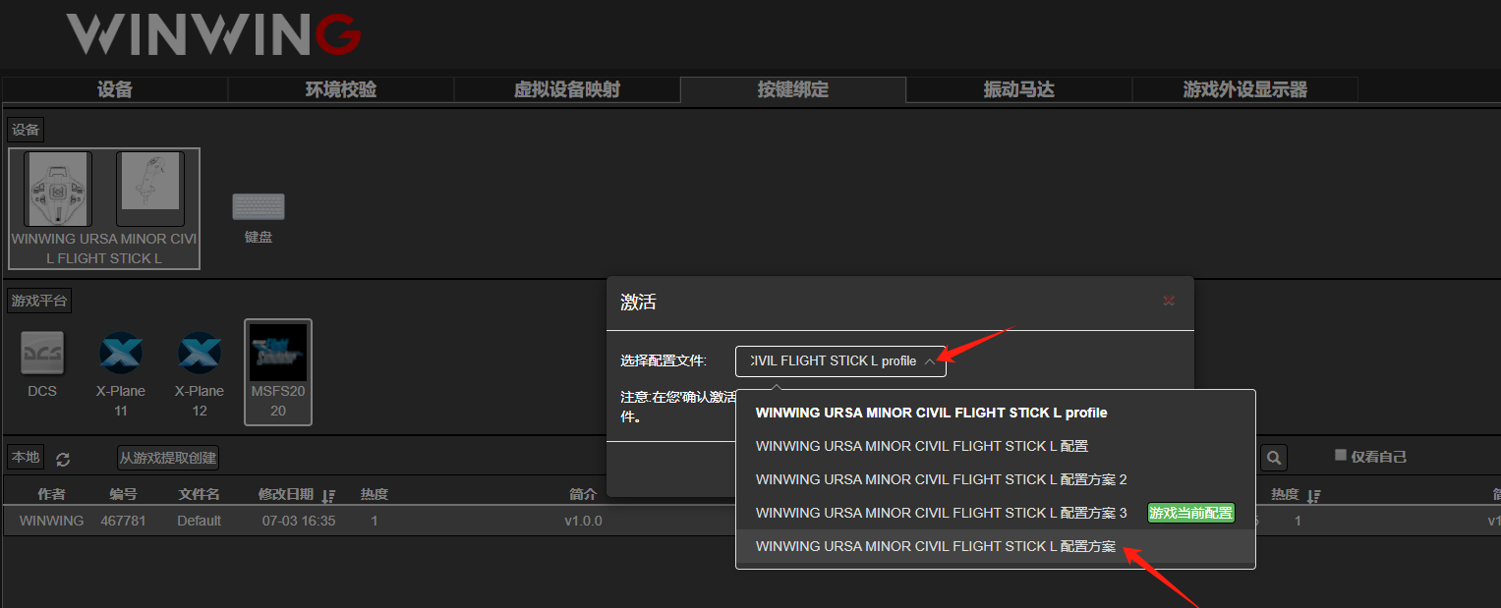
- Re-enter the game, in setting page, click control setting, select device, switch back and forth to check if the device config is applied successfully, then use the device to play game
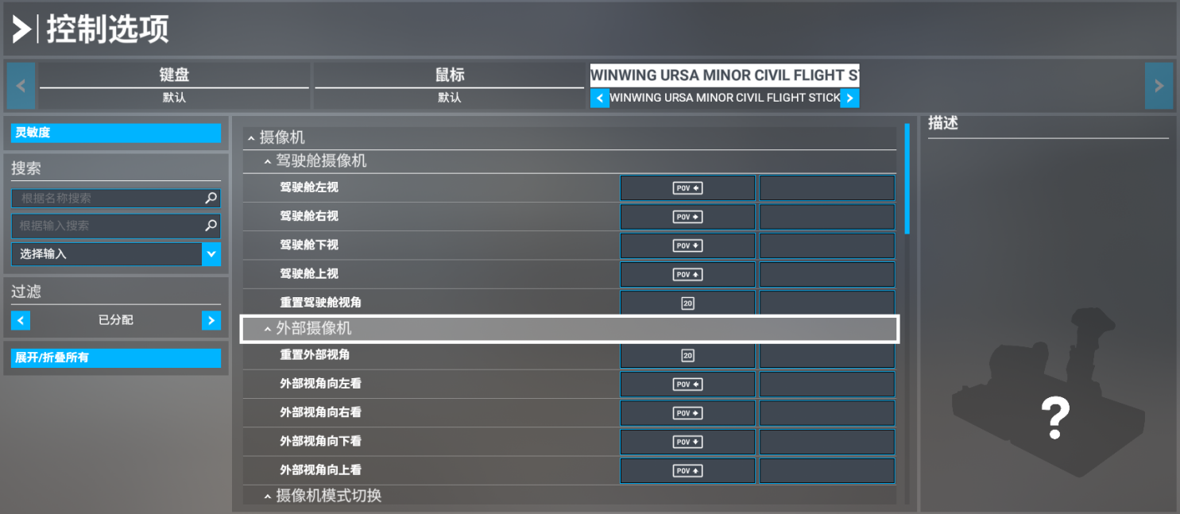
⑤ Key binding config share
In SIMAPP key binding page, click “create from game”, then input file name and description, the hit confirm button
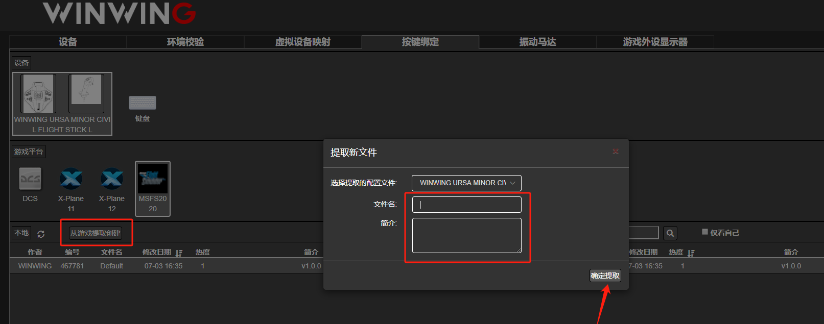
Then click “...” Button to share 